Notes: (1) You can create new function(s) if you see it is necessary. (2) In the main function: (a) Do not edit given statements. (b) Write statements in the indicated area only. (3) Suppose that a user enter data correctly, thus you do not need to write code to check input.
1.(2 marks, file to be edited: Q1.cpp)

Users are required to enter two integer variables a and b using the keyboard (STDIN), first sort a b by accending then find min of a and b;

Sample output:
6
5
OUTPUT
5 6
min=5
2.(2 marks, file to be edited: Q2.cpp). enter from keyboard value of x is float, n is integer;
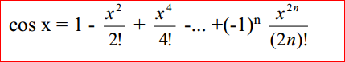
Sample output:
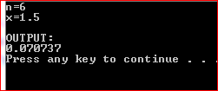

3.(3 marks, file to be edited: Q3.cpp)

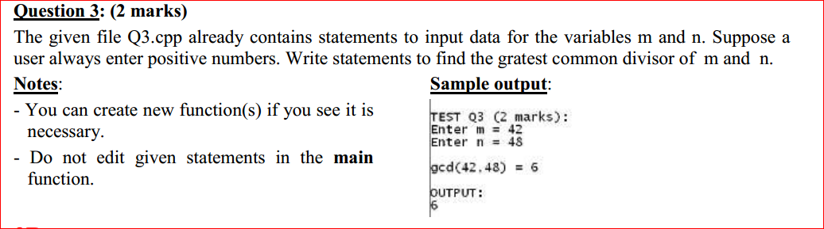

4.(2 marks, file to be edited: Q4.cpp)
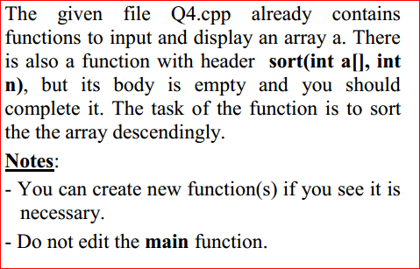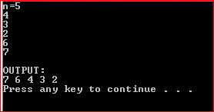

5.(2 marks, file to be edited: Q5.cpp)
Allows the user to enter 2 String s and p. Test string p in the s, if yes display “OKI” else display “ NOT OKI”
